Angle Measurement
# Source: AI Source: Provided by: [Data Path: Persons Table -> ID Column: 1, Name_En Column: Motasem Essam] -> From: [ChatGPT] on [7/17/2026]
Angle is the measurement of the amount of rotation or the opening between two rays, lines, or line segments that meet at a common point called the vertex. It is a fundamental quantity in mathematics, geometry, engineering, architecture, navigation, surveying, astronomy, and physics.
Angles describe direction, rotation, orientation, and the relationship between intersecting lines.

Definition
# Source: AI Source: Provided by: [Data Path: Persons Table -> ID Column: 1, Name_En Column: Motasem Essam] -> From: [ChatGPT] on [7/17/2026]
Angle is the quantity that measures the amount of rotation between two rays or line segments sharing a common endpoint (vertex).

Purpose
# Source: AI Source: Provided by: [Data Path: Persons Table -> ID Column: 1, Name_En Column: Motasem Essam] -> From: [ChatGPT] on [7/17/2026]
Angle measurement is used to:
- Describe geometric shapes.
- Measure rotation.
- Determine direction.
- Design structures.
- Construct engineering drawings.
- Perform surveying.
- Navigate land, sea, air, and space.
- Analyze motion in physics.

SI Unit
# Source: AI Source: Provided by: [Data Path: Persons Table -> ID Column: 1, Name_En Column: Motasem Essam] -> From: [ChatGPT] on [7/17/2026]
The SI derived unit of plane angle is the radian (rad).
$$1\text{ radian (rad)}$$
Although the radian is the SI unit, degrees (°) are the most commonly used unit in everyday applications.

Common Units of Angle
# Source: AI Source: Provided by: [Data Path: Persons Table -> ID Column: 1, Name_En Column: Motasem Essam] -> From: [ChatGPT] on [7/17/2026]
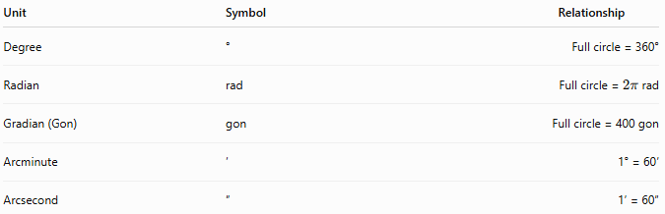
Unit | Symbol | Relationship
Degree | ° | Full circle = 360°
Radian | rad | Full circle = $2π$rad
Gradian (Gon) | gon | Full circle = 400 gon
Arcminute | ′ | 1° = 60′
Arcsecond | ″ | 1′ = 60″

Angle Conversions
# Source: AI Source: Provided by: [Data Path: Persons Table -> ID Column: 1, Name_En Column: Motasem Essam] -> From: [ChatGPT] on [7/17/2026]
Degrees and Radians
$$\text{Radians}=\text{Degrees}×\frac{π}{180} \\ \text{Degrees}=\text{Radians}×\frac{180}{π}$$
Examples:
- 180° = π rad
- 90° = π/2 rad
- 45° = π/4 rad
- 360° = 2π rad

Measuring Instruments
# Source: AI Source: Provided by: [Data Path: Persons Table -> ID Column: 1, Name_En Column: Motasem Essam] -> From: [ChatGPT] on [7/17/2026]
Angles are measured using:
- Protractor
- Bevel protractor
- Angle finder
- Clinometer
- Theodolite
- Digital angle gauge

Measurement Process
# Source: AI Source: Provided by: [Data Path: Persons Table -> ID Column: 1, Name_En Column: Motasem Essam] -> From: [ChatGPT] on [7/17/2026]
To measure an angle:
- Place the center of the protractor on the vertex.
- Align the baseline with one side of the angle.
- Read the value where the second side intersects the scale.
- Record the angle with the correct unit.

Types of Angles by Measure
# Source: AI Source: Provided by: [Data Path: Persons Table -> ID Column: 1, Name_En Column: Motasem Essam] -> From: [ChatGPT] on [7/17/2026]
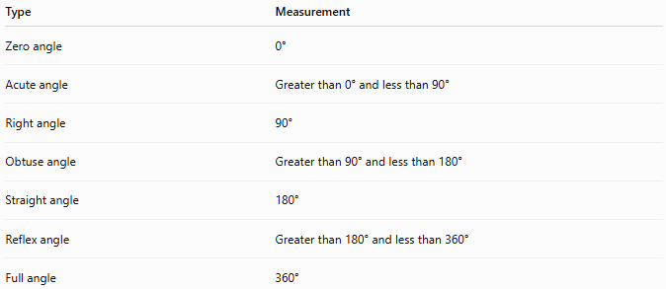
Type | Measurement
Zero angle | 0°
Acute angle | Greater than 0° and less than 90°
Right angle | 90°
Obtuse angle | Greater than 90° and less than 180°
Straight angle | 180°
Reflex angle | Greater than 180° and less than 360°
Full angle | 360°

Examples
# Source: AI Source: Provided by: [Data Path: Persons Table -> ID Column: 1, Name_En Column: Motasem Essam] -> From: [ChatGPT] on [7/17/2026]
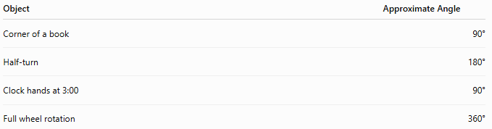
Object | Approximate Angle
Corner of a book | 90°
Half-turn | 180°
Clock hands at 3:00 | 90°
Full wheel rotation | 360°

Accuracy
# Source: AI Source: Provided by: [Data Path: Persons Table -> ID Column: 1, Name_En Column: Motasem Essam] -> From: [ChatGPT] on [7/17/2026]
Accurate angle measurement depends on:
- Correct alignment of the measuring instrument.
- Proper positioning of the vertex.
- Reading the correct scale.
- Instrument calibration.

Applications
# Source: AI Source: Provided by: [Data Path: Persons Table -> ID Column: 1, Name_En Column: Motasem Essam] -> From: [ChatGPT] on [7/17/2026]
Angle measurement is essential in:
- Geometry
- Trigonometry
- Engineering
- Architecture
- Construction
- Surveying
- Navigation
- Astronomy
- Robotics
- Mechanical design

Everyday Importance
# Source: AI Source: Provided by: [Data Path: Persons Table -> ID Column: 1, Name_En Column: Motasem Essam] -> From: [ChatGPT] on [7/17/2026]
Angle measurement is used for:
- Building construction.
- Furniture assembly.
- Road design.
- Roof construction.
- Sports analysis.
- GPS navigation.
- Photography.
- Machine alignment.

Common Mistakes
# Source: AI Source: Provided by: [Data Path: Persons Table -> ID Column: 1, Name_En Column: Motasem Essam] -> From: [ChatGPT] on [7/17/2026]
- Reading the wrong scale on a protractor.
- Misplacing the center of the protractor.
- Confusing degrees and radians.
- Measuring from the wrong baseline.
- Forgetting the unit.

Key Points
# Source: AI Source: Provided by: [Data Path: Persons Table -> ID Column: 1, Name_En Column: Motasem Essam] -> From: [ChatGPT] on [7/17/2026]
- Angle measures the amount of rotation or opening between two intersecting rays or lines.
- The SI unit is the radian (rad).
- The degree (°) is the most commonly used practical unit.
- Angles are measured using protractors, theodolites, and digital angle gauges.
- Angle measurement is fundamental in geometry, engineering, navigation, and physics.

Angle vs. Rotation
# Source: AI Source: Provided by: [Data Path: Persons Table -> ID Column: 1, Name_En Column: Motasem Essam] -> From: [ChatGPT] on [7/17/2026]
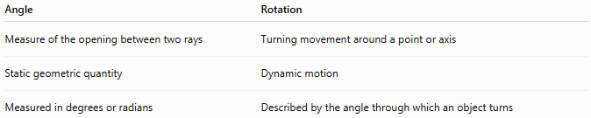
Angle | Rotation
Measure of the opening between two rays | Turning movement around a point or axis
Static geometric quantity | Dynamic motion
Measured in degrees or radians | Described by the angle through which an object turns

Angle vs. Direction
# Source: AI Source: Provided by: [Data Path: Persons Table -> ID Column: 1, Name_En Column: Motasem Essam] -> From: [ChatGPT] on [7/17/2026]
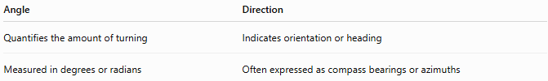
Angle | Direction
Quantifies the amount of turning | Indicates orientation or heading
Measured in degrees or radians | Often expressed as compass bearings or azimuths

Angle vs. Slope
# Source: AI Source: Provided by: [Data Path: Persons Table -> ID Column: 1, Name_En Column: Motasem Essam] -> From: [ChatGPT] on [7/17/2026]
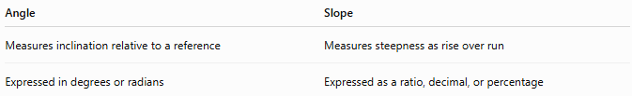
Angle | Slope
Measures inclination relative to a reference | Measures steepness as rise over run
Expressed in degrees or radians | Expressed as a ratio, decimal, or percentage

Conclusion
# Source: AI Source: Provided by: [Data Path: Persons Table -> ID Column: 1, Name_En Column: Motasem Essam] -> From: [ChatGPT] on [7/17/2026]
Angle is the measurement of the amount of rotation or the opening between two rays or line segments that meet at a common vertex. It is an SI derived quantity, with the radian (rad) as its standard unit, while the degree (°) is the most widely used unit in practical applications. Accurate angle measurement, using instruments such as protractors, angle finders, and theodolites, is essential in mathematics, engineering, architecture, navigation, surveying, astronomy, and many everyday activities involving orientation, rotation, and geometric design.

